Madonna Journal of Medicine and Health Sciences
Volume 2 issue 1 (2022), Pp. 49 - 62
© Madonna University Press, Inc. 2022
http://madonnauniversity.edu.ng/journals/index.php/medicine

ISOLATION AND CHARACTERIZATION OF FUNGI ASSOCIATED WITH STALED BREAD IN MADONNA UNIVERSITY ELELE CAMPUS FEMALE HOSTEL

Anyamaobi P. Okiemute¹, *Emmanuel Ifeanyi Obeagu^{1,2} https://orcid.org/0000-0002-4538-0161, Issac N Nnatuanya¹, Arvin Nwakulite¹ and Margaret Orabi Ukpata¹

¹Department of Medical Laboratory Science, Madonna University, Elele Campus, Elele, Rivers State, Nigeria.
²Department of Medical Laboratory Science, Imo State University, Owerri, Imo State, Nigeria.

emmanuelobeagu@yahoo.com

ABSTRACT
Bread is the most important staple food in the Western world and it is recognized as a perishable commodity, which is at its best when consumed 'fresh'. Unfortunately, bread remains 'fresh' for only a few hours after it leaves the oven. Isolation and characterization of fungi associated with staled bread in female hostel was investigated. The aim of this research is to examine the fungi associated with staled bread in Madonna University Elele campus female hostel. The bread sample used for this study was collected from different female hostel in Madonna university, the glass wares were sterilized properly in hot air oven at 160⁰c for two hours, other materials were sterilized by autoclaving at 121⁰C for 15minutes.The culture media used for this experiment is sabouraud Dextrose agar (SDA) which is known to support the growth of only fungal organisms. The organisms found to be associated with the spoilage of bread were strictly fungal organisms which include; Mucor spp. (30%), Rhizopus spp. (17%), Penicillium spp. (17%), Fusarium spp. (3%). However, the percentage distribution of fungal organism isolated from staled bread in different female hostel of Madonna University Elele Campus showed that Omogo hostel had the highest percentage of 23% followed by Madonna hostel (21%), Barnabas hostel (17%), St. Anthony hostel (15%), MJS hostel (15%), Edeani hostel (8%). After analyzing the samples, Aspergillus spp was found to be the most occurring fungi in bread.
Keywords: isolation, characterization, fungi, staled bread

INTRODUCTION
Bread is the most important staple food in the Western world and it is recognized as a perishable commodity, which is at its best when consumed 'fresh'. Unfortunately, bread remains 'fresh' for only a few hours after it leaves the oven. During storage it is subjected to a number of changes which lead to the loss of its organoleptic freshness. The factors that govern the rate of freshness loss in bread during storage are mainly divided into two groups; those attributed to microbial attack, and those that are result of a series of slow chemical or physical changes which lead to the progressive firming up of the crumb, commonly referred to as 'staling'. Microbiological spoilage of bread the most common source of microbial spoilage of bread is mould growth. Less common, but still causing problems in warm weather, is the bacterial spoilage condition known as 'rope' caused by growth of Bacillus species. Least common of all types of microbial spoilage in bread is that caused by certain types of yeast.
The scientific names of fungi that grow on bread are; Rhizopus nigricans and Mucour stolonifer (Banwart, 2004). There are minor differences between the two and both are commonly referred to as “Bread mold”. These are invariably the first one to “arrive” and germinate on a piece of bread. Later, many others may follow such as Aspergillus and Penicillium (Hocky, 2008). Yeast is used in the dough of the bread to release CO2 and makes the bread spongy and fluffy. Bread is one of the oldest prepared foods. Evidence from 30,000 years ago in Europe revealed starch residue on rocks used for pounding plants. It is possible that during this time, starch extract from the roots of plants, such as cattails and ferns, was spread on a flat rock, placed over a fire and cooked into a primitive form of flatbread. Around 10,000 BC, with the dawn of the Neolithic age and the spread of agriculture, grains became the mainstay of making bread. Yeast spores are ubiquitous, including the surface of cereal grains so any dough left to rest will become naturally leavened. There were multiple sources of leavening available for early bread. Airborne yeasts could be harnessed by leaving uncooked dough exposed to air for some time before cooking.
The research was done to examine the fungi associated with Staled bread in Madonna university female hostel.
MATERIALS AND METHODS
STUDY AREA
The study was carried out in Madonna University female hostels, Elele Campus, River state.
MATERIALS
The material used in this study include; Sabouraud Dextrose agar, Brain Heart Infusion, Aluminium foil, Spirit lamp, Petri dishes, Measuring cyclinder, Conical flask, Refrigerator, Staining rack, Incubator, Hot air oven, Weighing balance.

STERILIZATION OF MATERIAL
Media prepared was sterilized in an autoclave at 121ºc for 15minutes, all glass wares sterilized in a hot air oven at 160ºc for 1 hour. Before the glass wares were sterilized in hot air oven they meticulously washed with detergent, rinsed in distilled water.
METHODOLOGY
The methods used in this experiments were carried out according to standards recommended by the following researchers (Alexander (1999), Harrigan (1988), Dubey and Maheshawi (2004).
SAMPLE SIZE
The sample size that was used in this work was calculated using Lesile Kish formular (kish., 1995):
N = Z² X P (1-P)/d²
Where;
N = Minimum sample size
D = desired level of significance (0.5)
Z = confidence interval (1.96)
P = prevalence rate 6%
60 samples where used
COLLECTION OF SAMPLES
The 60 rolls of bread used for this study were purchased from different hostels in Madonna university Elele campus female hostel Rivers State, Nigeria. The samples collected were transported in a sterile polyethylene bag to the laboratory for analysis.
MEDIA PREPARATION
The culture media used for this experiment is the sabouraud dextrose agar (SDA) which is known to support the growth of only fungi organisms and the Brian heart infusion agar. The media was prepared according to the manufacturer‟s directions.
All the glass wares used for this study were sterilized properly in a hot air oven at 160⁰C for an hour. Other materials were sterilized by autoclaving at 121⁰C for 15minutes.
32.5g salt was weighed out with a weighing balance for 500mls of water. The two mixtures were mixed together and sealed with aluminum foil and autoclaved at 121^{O}C for 15minutes.
ISOLATION OF FUNGI
The samples were kept in different female hostels of Madonna University for 5 days. It was then transported to the laboratory in a black polyethylene bag.
The total of 60 rolls of bread samples were used in this research. Sterile Petri dishes were aligned and Sabouraud Dextrose Agar (DSA) media already prepared were poured into the Petri dishes, they were allowed to gel. The plates dried in inverted position. 1g of each of the sample was matched and spread on the media plate. It was sealed with paper tape and then incubated for 5 days at 27⁰C for colony formation. The count was determined by counting the corresponding colonies that were observed. Spread plating techniques was used for discrete colonies. The count was recorded in colony forming unit per ml (CFU)ml).
RESULT
After incubation period, the total fungal count of bread samples over a storage period of 5 days is shown below;
There was no fungal count on the first two days of study for the sixty (60) samples used. On the third day of the study, twenty-nine (29) out of the sixty (60) samples had scant fungal count. However, all the samples showed positive fungal growth from the fourth day till the fifth day.
Table 1 shows the percentage occurrence of positive and negative growth of fungal organism isolated from staled bread collected from Madonna University female hostel with a hundred percent growth.
Table 2 shows the percentage distribution of fungal isolated from staled bread collected in Madonna University Elele Campus female hostel. Mucor spp, Fusarium spp, Aspergillus spp, Rhizopus spp, and Penicillium spp. were isolated.
Table 4.3 shows the percentage distribution of fungal isolated from staled bread collected within different female hostel in Madonna University Elele Campus. Aspergilus spp has the highest percentage of 33 followed by Mucor spp. (30%), Rhizopus spp. (17%), Penicillium spp. (17%), Fusarium spp. (3%).

TABLE 1: Percentage Occurrence of Positive and Negative Fungal Organism Isolated from Staled Bread in Different Madonna University Female Hostels
Location No. Of Samples No. Of Possitive% No. Of Negative% P. Value
Madonna 10 10(100) 0(0) 0.4
Hostel
Edeani 10 10(100) 0(0) 0.0
Hostel
Mjs 10 10(100) 0(0) 0.26
Hostel
Omogo 10 10(100) 0(0) 0.0
Hostel
Barnabas 10 10(100) 0(0) 0.12
Hostel
Total 60 60(100) 0(0)
KEY: NO = NUMBER
*P< 0.05
TABLE 2: Percentage Distribution Of Fungi Isolated From Staled Bread In Madonna University Female Hostel
Fungal Isolates Number Percentage P.Value
Fusarium spp 2 3 0.28
Rhizopus spp 10 17 0.18
Penicillium spp 10 17 0.00
Mucor spp 18 30 0.88
Aspergilus spp 20 33 .482
TOTAL 60 100
*P < 0.05
TABLE 3: the percentage distribution of fungi isolates within different location of the female hostel used in Madonna University Elele Campus
Fungal Madonna St. Anthony Edeani Mjs Omogo Barnabas Total
Isolate Hostel Hostel Hostel Hostel Hostel Hostel
Rhizopus 2(15) 3(33) 0(0) 3(33) 2(4) 0(0) 10(17)
Spp
Aspergilus 3(23) 2(22) 3(60) 2(22) 5(36) 5(50) 20(33)
Spp
Mucor 4(31) 2(22) 2 (40) 2 (22) 5(36) 3(30) 18(30)
Spp
Penicillium 2(15) 2(22) 0(0) 2(22) 2(14) 2(20) 10(17)
Spp
Fusarium 2(15) 0(0) 0(0) 0(0) 0(0) 0(0) 2(3)
Spp
Total 13 (22) 9(15) 5(8) 9(15) 14(23) 10(17) 60(100)

*=P<0.05

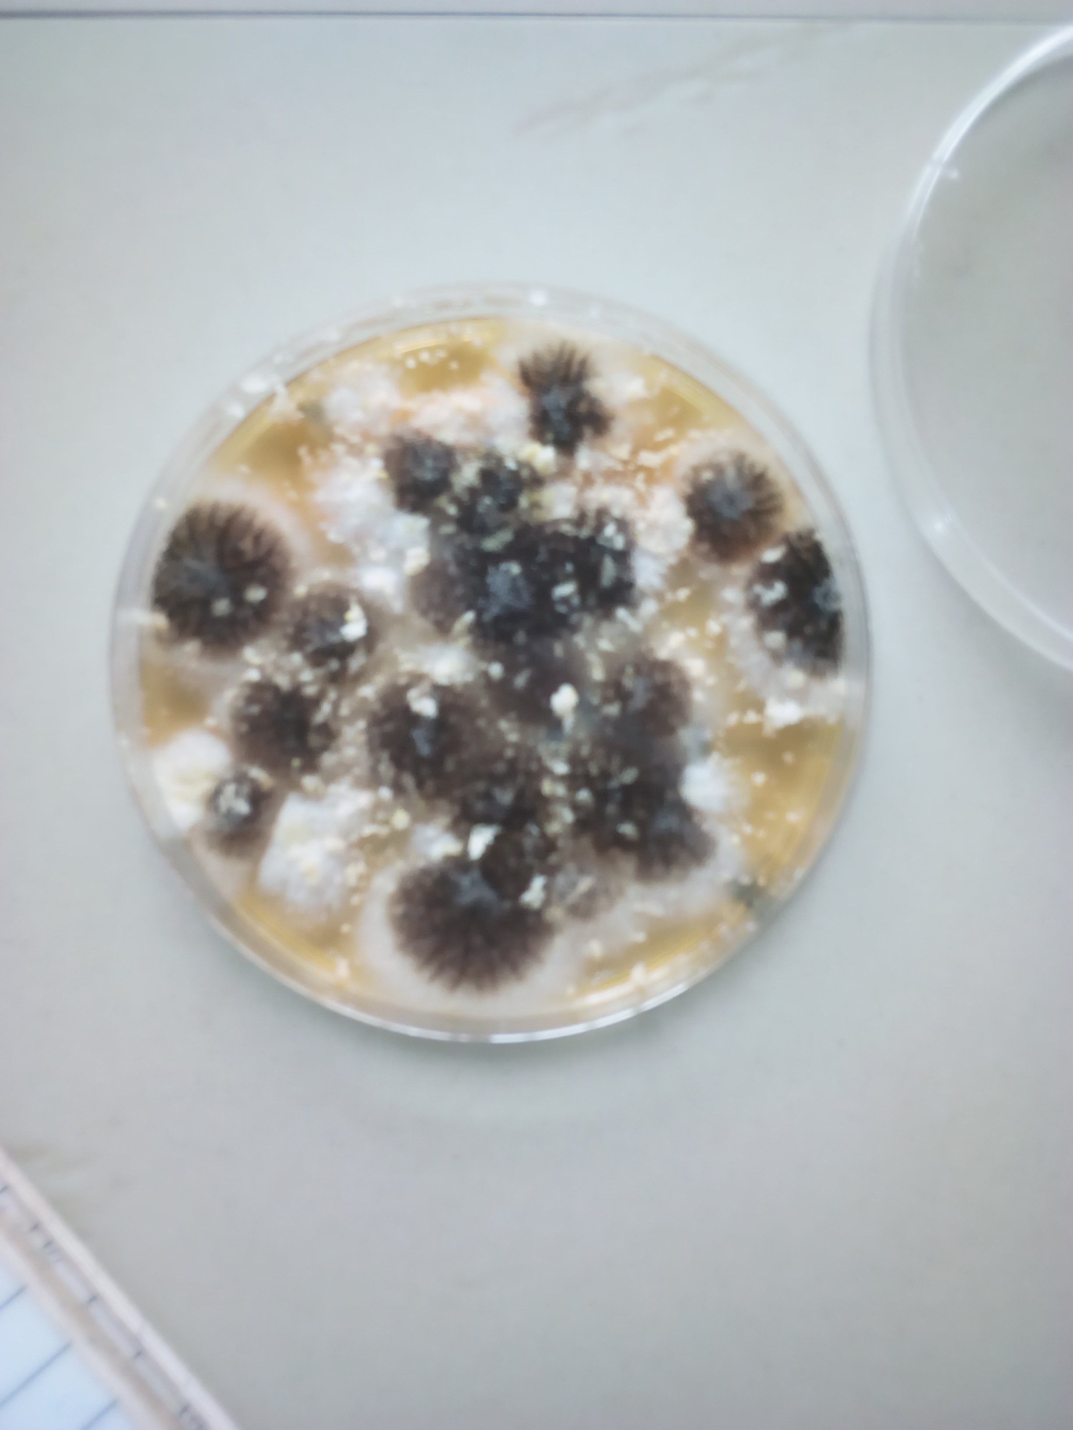
Figure 1: Showing the cultural morphological characteristics of Aspergilus spp
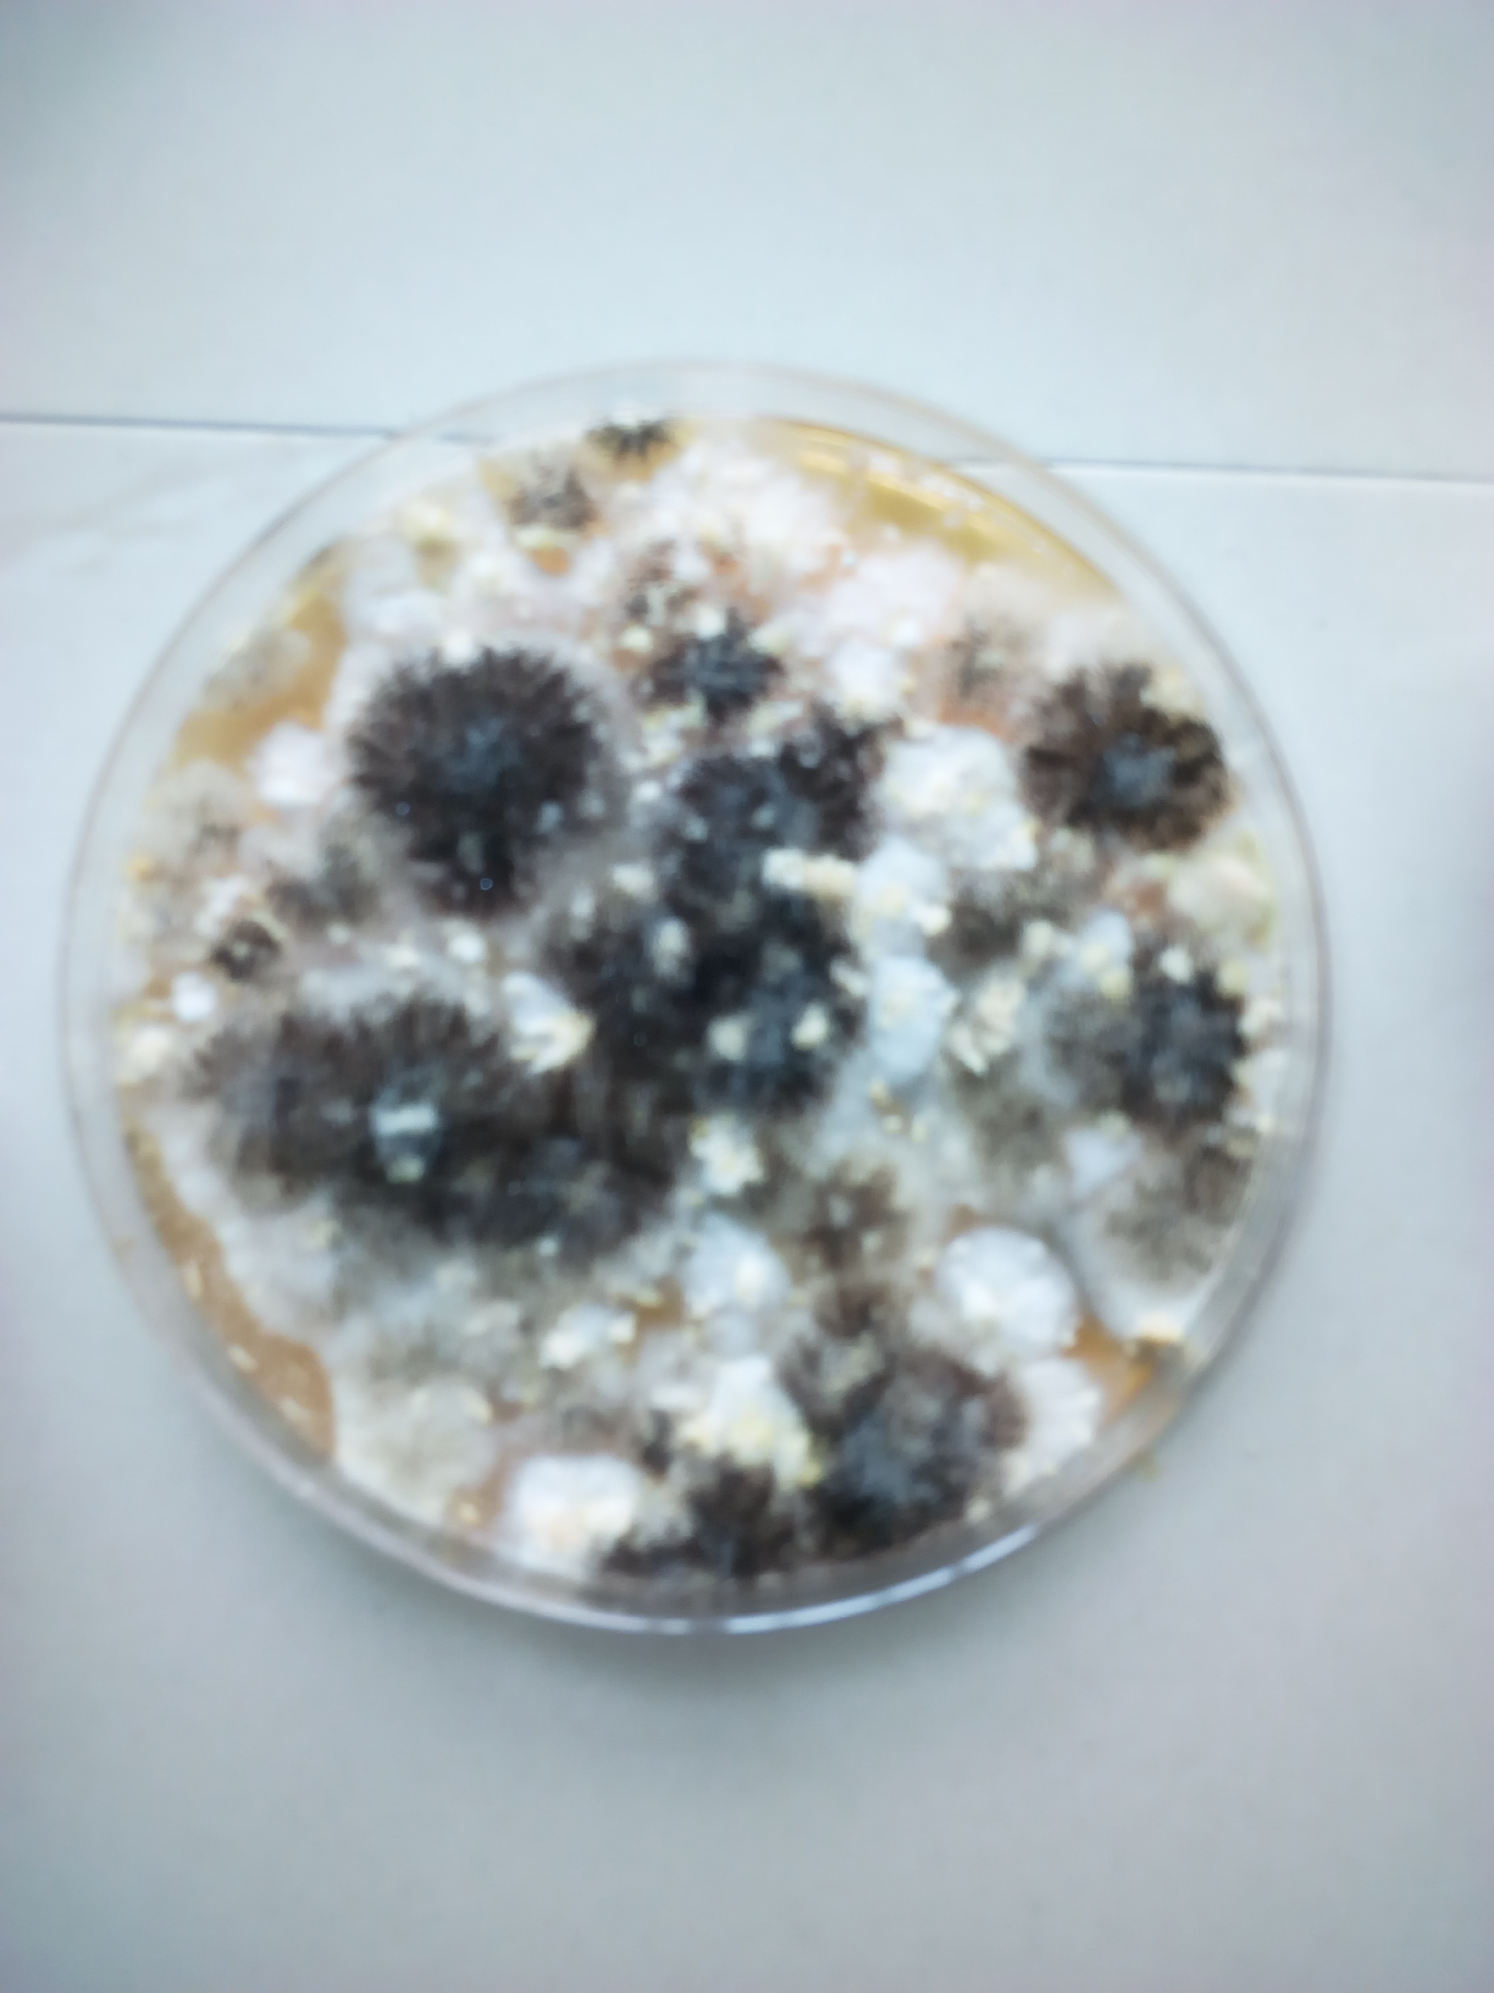
Figure 2: Showing the cultural morphological characteristics of Aspergilus spp and Rhizopus Spp
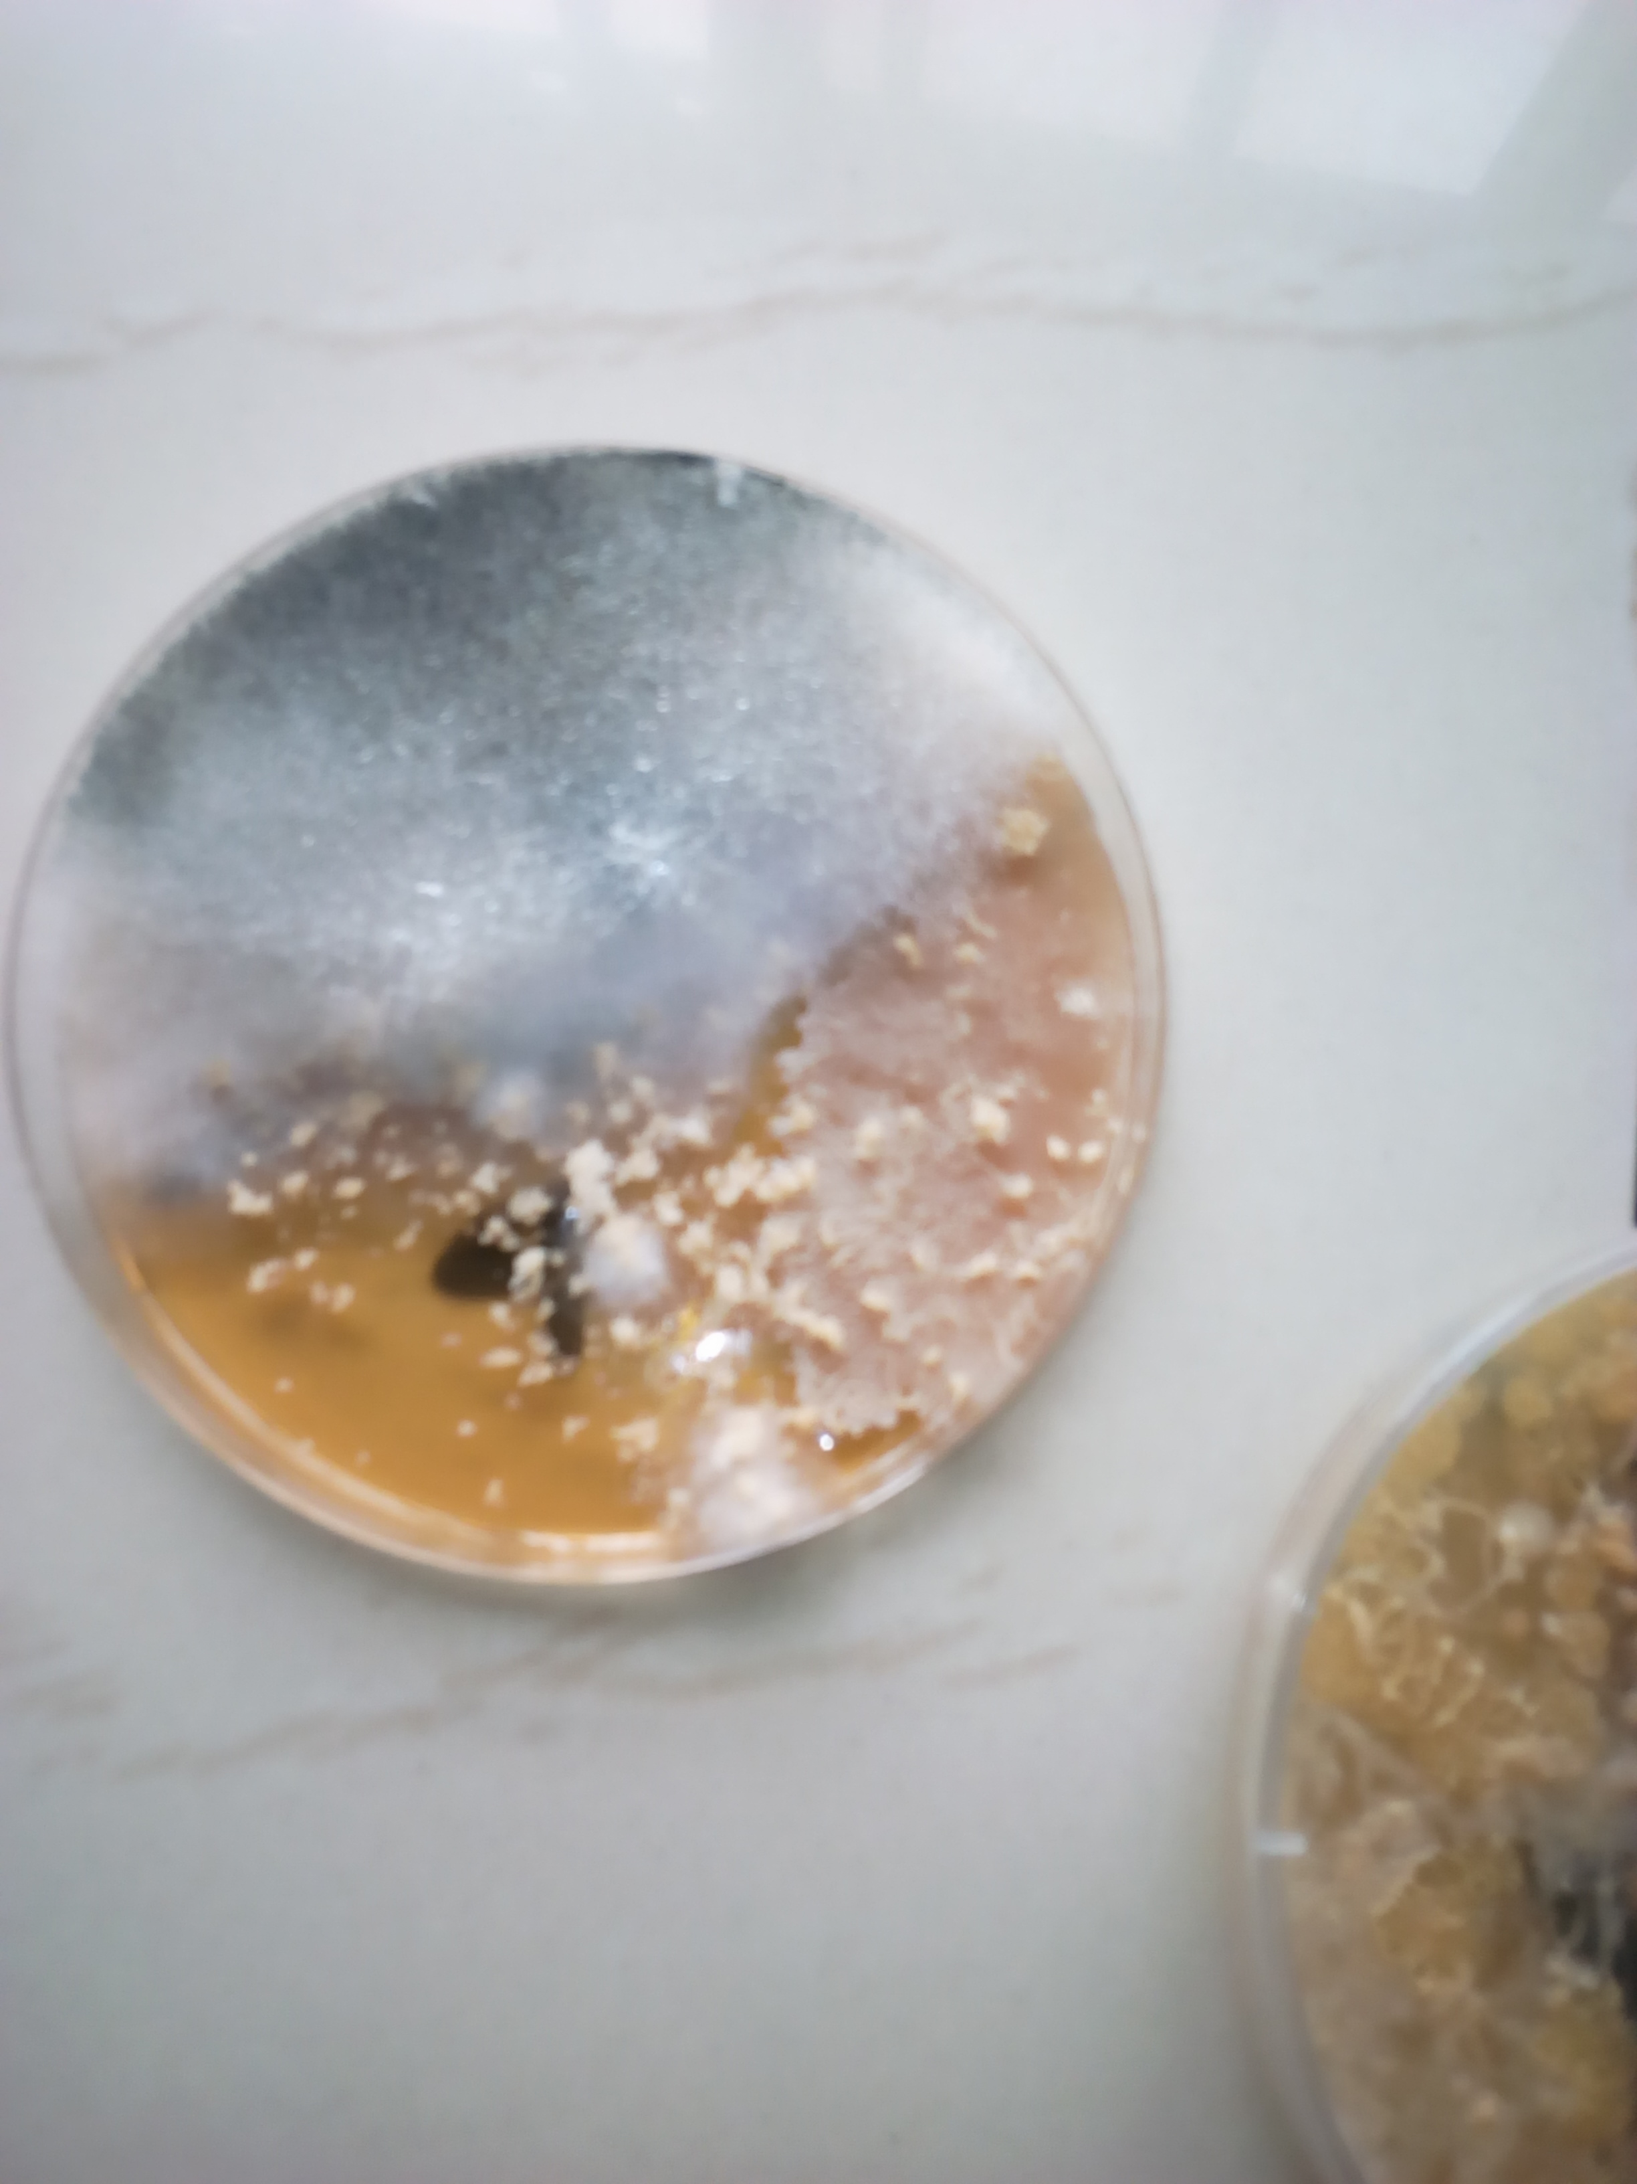
Figurer 3: Showing the cultural morphological characteristics of Penicillum spp
DISCUSSION
The study was done to isolates the fungi associated in staled bread in Madonna University Elele Campus Female Hostel. A total number of 60 samples were collected during the course of this research. After incubation period, the total fungal count of bread samples over a storage period of 5 days is shown in Table 4.1. There was no fungal count on the first two days of study for the sixty (60) samples used. On the third day of the study, twenty-nine (29) out of the sixty (60) samples had scanty fungal count. However, all the samples showed positive fungal growth from the fourth day till the fifth day with similar findings by Gide et al., (2016). There was no significant difference i.e. p <0.05. The observations show 100% growth of fungal organism.
The fungal load (count) increased progressing as the period of storage increased. The fifth day therefore showed the highest fungal count for all examined samples. The fungal organism isolated from this study includes; Mucor spp, Fusarium spp, Aspergillus spp, Rhizopus spp, and Penicillium spp. Of which Aspergilus spp has the highest percentage of 33 followed by Mucor spp. (30%), Rhizopus spp. (17%), Penicillium spp. (17%), Fusarium spp. (3%) This is in line with a similar work by Gouse et al., (2015) their findings had a total number of 100% fungal isolates belonging to 5 genera namely Mucor spp, Fusarium spp, Aspergillus spp, Rhizopus spp, and Penicillium spp.
From this study, the percentage distribution of fungal organism isolated from staled bread used within different female hostel in Madonna University Elele Campus showed that Omogo hostel had the highest percentage of 23 followed by Madonna hostel (21%), Barnabas hostel (17%), St. Anthony hostel (15%), MJS hostel (15%), Edeani hostel (8%). (Table 3), this is in agreement with a similar finding by Gouse et al., (2015) whose observation showed that hostels had the highest frequency percentage. There was significant difference p<0.05
CONCLUSION
The findings of this study revealed that staled bread in Madonna University, Elele Campus Female hostels were contaminated with various Fungi. This indicates inadequate and poor maintenance of the Hostels. The presence of the Fungi is an indication of improper cleaning of the rooms by the Hostels occupants. These Fungi could result to respiratory tract infections e.g., sinusitis, aspergillosis etc. of which these breads can serve as medium to their transmission to individuals. These diseases can easily affect immune compromised individuals.
REFERENCES
Alexander, M. (1999). The Mycoflora of Corn Silage. Journal of Veterinary Medicine, 23 (1), 57.
Banwart, G. J. 2004. Basic Food Microbiology. A Westport Publication, 505 – 544.
Dubey, R.C., & Maheshwari, D. K. (2004). Practical Microbiology. S. S. Chad and Company LTD, 221 – 231.
Gouse, B., Ali Ismail, A., Zafer, S. & Omar, B. (2015). Assessment of Bacteria and Fungi in Air from College of Applied Medical Sciences (Male) at AD-Dawadmi, Saudi Arabia. International Research Journal of Biological Sciences. 4(9), 48-53.
Harrigan, W. F. (1988). Laboratory Methods in Food and Diary Microbiology, Academic Press Inc, 495.
Hocking, A. D. (2008). Mould and Yeast Associated with Foods of Reduced Water Activity. Ecological Interactions. In: Seow, C. C (Ed), Food Preservation by Moisture Control. Elsevier, 57 – 72.

